ENTRY FORM

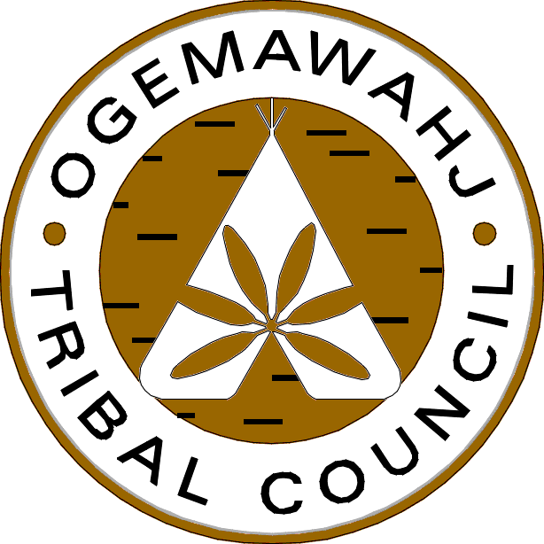
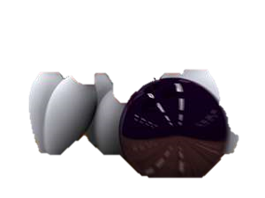

The OTC welcomes you to the 3rd Annual Golf Tournament.
New *** All teams must have one girl

TEAM NAME:
Names of Team Members: |  | Title/Position within Organization, Business or Agency and email address:
1
2
3
4
TEAM CAPTAIN'S NAME:
What is your team’s Networking Relationship to Ogemawahj Tribal Council or its Member Nations, e.g. FN Member, Friend, Relative, Business, etc.?
Mailing Address:
Phone Number:
Email address:
Website:
Kindly complete and send entry forms by email to Sherry Garcia at sgarcia@ogemawahj.on.ca

